[Moroccan Split Pea Stew](http://www.thefitcook.net/home/moroccan-split-pea-stew)

2/16/2012

[8 Comments](http://www.thefitcook.net/home/moroccan-split-pea-stew#comments)

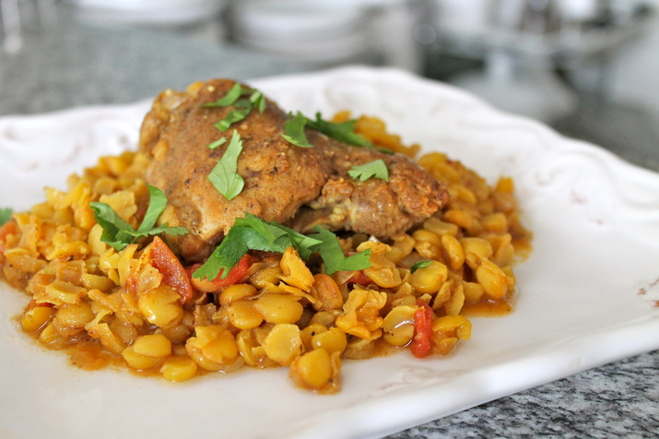

Moroccan Split Pea Stew  
Adding spices is the best way to make food that is flavorful with little to no fat - that's how this dish went from ordinary to Moroccan. I am a huge fan of legumes (beans, lentils, chickpeas) because they are very nutritious and you can make a lot for very little money. Cook once, enjoy over and over.

[**24**](http://www.thefitcook.net/home/moroccan-split-pea-stew)

***Serves 4-6  
Ready in: 1 hour  
  
You'll Need:***  
1 1/2 tablespoons curry powder  
1 1/2 tablespoons ground coriander  
1/2 tablespoon cumin  
1 teaspoon cinnamon  
1 1/2 pounds skinless chicken thighs   
3 tablespoons olive oil, divided  
1 large white onion, chopped  
3 garlic cloves, crushed  
1/4 teaspoon red pepper flakes   
1 14-ounce bag of yellow split peas, rinsed and drained  
1 14-ounce can crushed tomatoes  
1/2 cup fresh cilantro, chopped  
  
***Here's How:***  
1. In a small bowl, combine the curry powder, coriander, cumin, and cinnamon.  
2. Use kitchen shears to trim the excess fat from around the chicken thighs. Season with some of the spices, and salt and pepper on both sides.   
3. Heat 2 tablespoons of olive oil in a large soup pot over medium-high heat. Add the chicken in an even layer. Cook the thighs for 3-5 minutes on each side, or until browned. Transfer the chicken to a plate.  
4. Add the remaining olive oil to the pot, along with the onion, garlic, red pepper flakes, and what's left of the spices. Season with salt and pepper. Cook about 5 minutes, or until the onion is soft.  
5. Add the split peas, crushed tomatoes, and 7 cups of water to the pot. Bring to a boil, then reduce to a simmer.  
6. Add the chicken back into the pot. Cook covered for at least 40 minutes, or until the split peas are cooked through and tender. Taste for seasoning, adding more salt and pepper if needed.  
7. To serve, ladle the split peas onto a plate. Top with a chicken thigh and garnish with fresh cilantro.